To Whom It May Concern:

The Earnest Money Deposit in the amount of $5,500 for 13968 Cannondale Way Gainesville, VA 20155 was deposited on 06/05/2019 from April Meyer. Below is the deposit confirmation along with the front and back copy of the check from our financial institution.

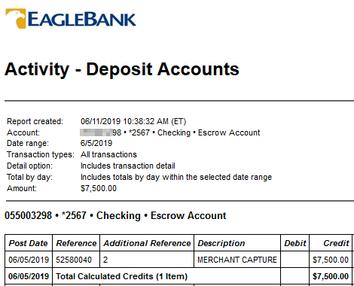

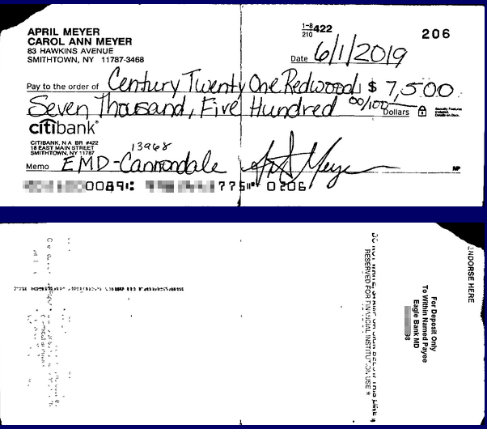

Sincerely,

**Marnilyn Ramirez**  
Commissions Director

Century 21 Redwood Realty

Office: (703)790-1850 x 1860

mramirez@c21redwood.com